

Suspension Processing

Manufacturing Procedure

Purpose

The purpose of this manufacturing procedure is to provide instructions for the processing of the unpurified polymeric dispersion solution CHEMPSBTCI010 (M.SLQ001) into the Suspension component (C.SLQ001) using the KrosFlow® KTF-2000 Diafiltration System.

Scope

This procedure is applicable to the production of the Suspension component (C.SLQ001) for Silq Technologies. The suspension is used to apply the Silq surface treatment (coating) to catheters.

Documents

Associated Documents / Forms

QC-C.SLQ001 Quality Control Procedure, Suspension Analysis

TR-C.SLQ001 Suspension Processing Traveler

QM.SLQ049 Workstation Practices SOP

QM.SLQ051 Environmental Monitoring SOP

Definitions

Abbreviations / Acronyms

COA – Certificate of Analysis

DFV – Designated Fill Volume

DOV – Designated Operating Volume

General Definitions

N/A

Responsibilities

It is the responsibility of Manufacturing/Operations management or their authorized representative to ensure this procedure is adequate and appropriate for fulfilling the purpose of this document.

It is the responsibility of Silq personnel and approved contractor personnel to perform their job duties in compliance with the requirements of this procedure and its associated procedures, as appropriate, including ensuring that any output documentation from this procedure is complete and accurate.

Safety Information

Gloves (latex or nitrile) and safety eye wear are to be worn at all times during the execution of this procedure.

This procedure shall be executed in the designated area under a fume hood.

Equipment / Tools / Fixtures

KrosFlo KTF-2000 Diafiltration System (E.SLQ006)

High Purity Water Tank Assembly, 750 gallon (E.SLQ002)

Waste Tank Assembly, 500 gallon (E.SLQ004)

Waste diaphragm pump (E.SLQ003)

Concentrate Reactor (E.SLQ009)

Concentrate Reactor Floor Scale (E.SLQ010)

Large Flow Peristaltic Pump (E.SLQ011)

Suspension Floor Scale (E.SLQ012)

Pneumatic Drum Stirrer (E.SLQ007)

Portable Exchange Deionizer System (E.SLQ001)

Dymo LabelWriter 5XL Label Printer with Dymo Connect Software

Components / Materials / Supplies

Polymeric Dispersion Solution, Unpurified (M.SLQ001)

Label Stock, 4” x 6”, White (C.SLQ002)

Drum, Plastic, 55 gallon, Closed Top (Product Tank) (C.SLQ003)

High Purity Water (S.SLQ001)

Centrifuge tube, 50 mL, Polypropylene, Flat Cap (S.SLQ002)

Container, 8.5” x 18” x 6” (S.SLQ003)

Bleach (S.SLQ007)

Permanent pen

Suspension Processing Equipment and Layout

System Diagram: See Appendix A for system diagram for the suspension processing. The system diagram identifies the equipment, tubing, valves, and fittings required for processing the suspension at the Chico facility.

Image of KTF-2000 System
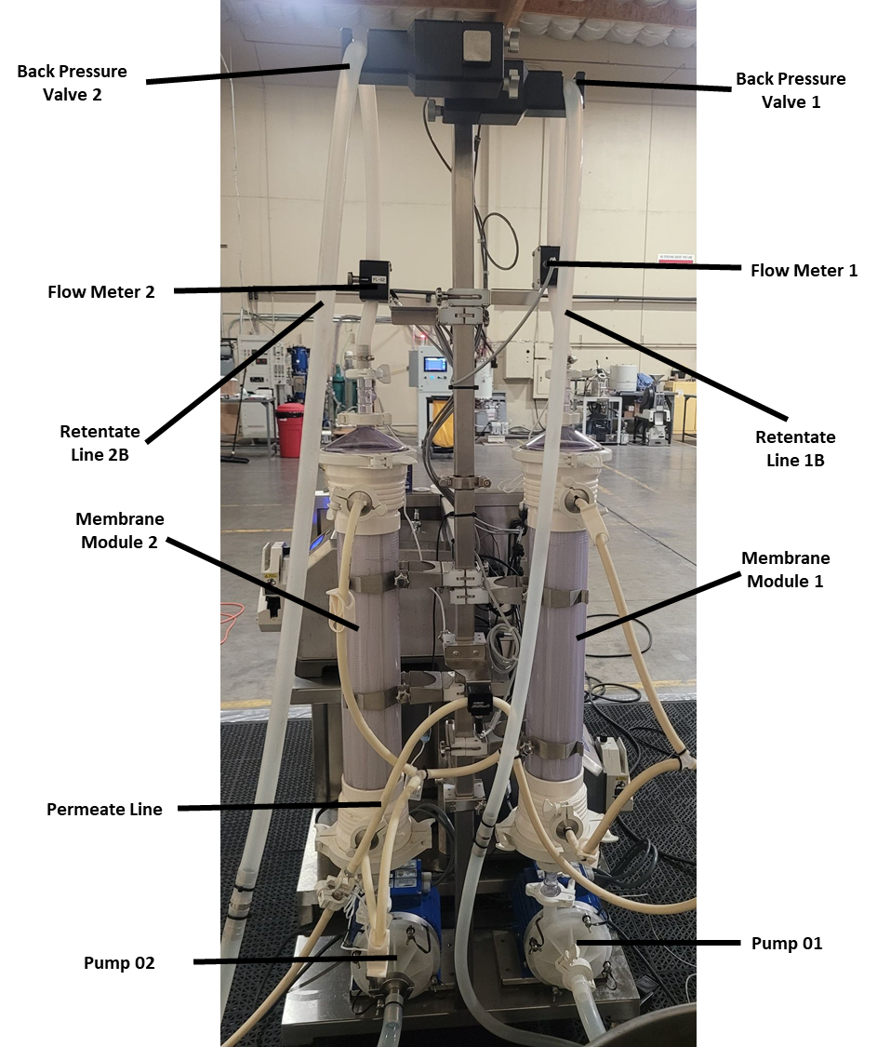

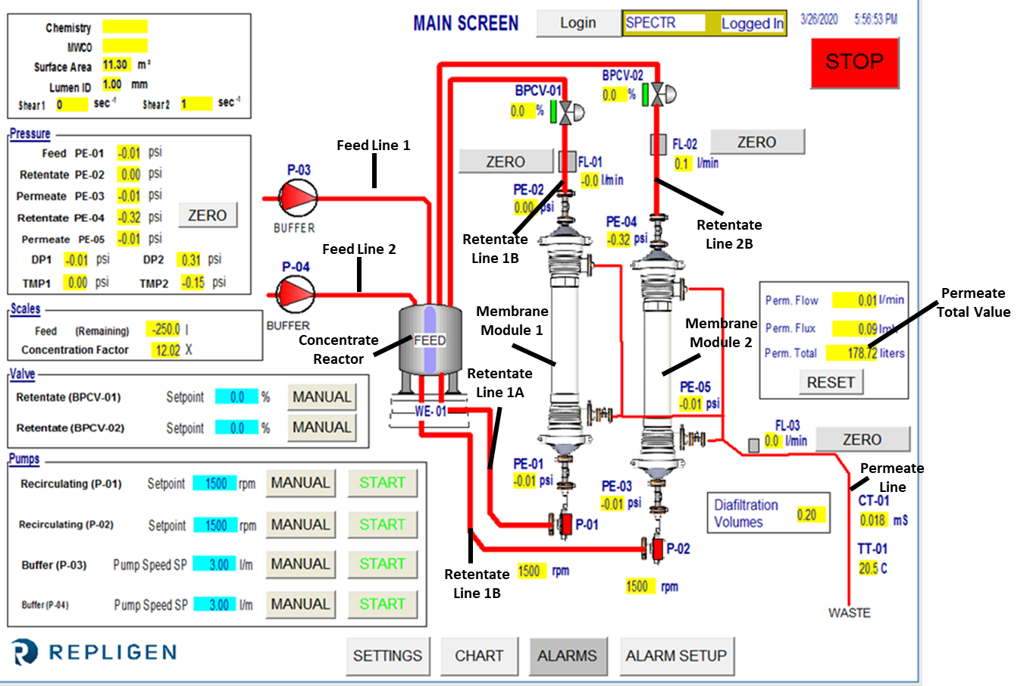
KTF System Software screenshot

Concentrate Reactor, pneumatic drum stirrer and connecting lines
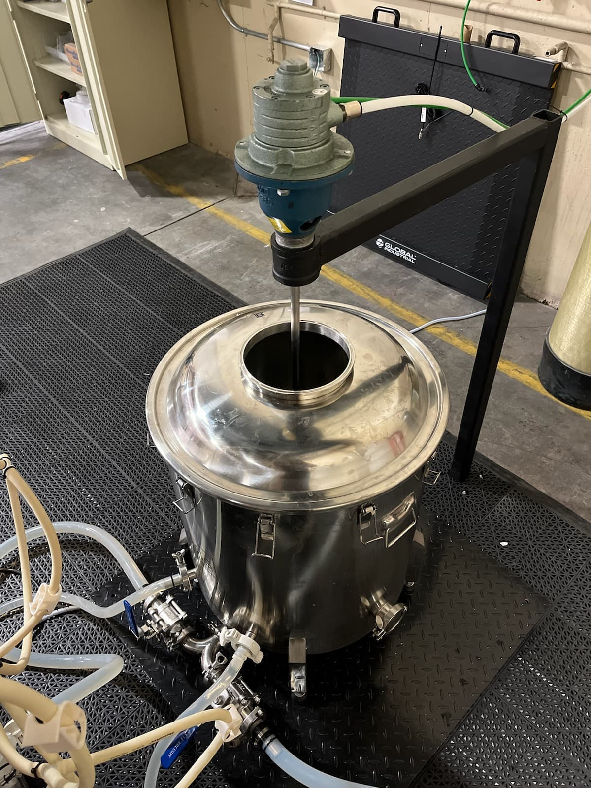
Retentate Line 1A
Retentate Line 1B
Concentrate Reactor (E.SLQ009)
Retentate Line 2A
Retentate Line 2B
Concentrate Reactor Floor Scale (E.SLQ010)
Pneumatic Drum Stirrer (E.SLQ007)

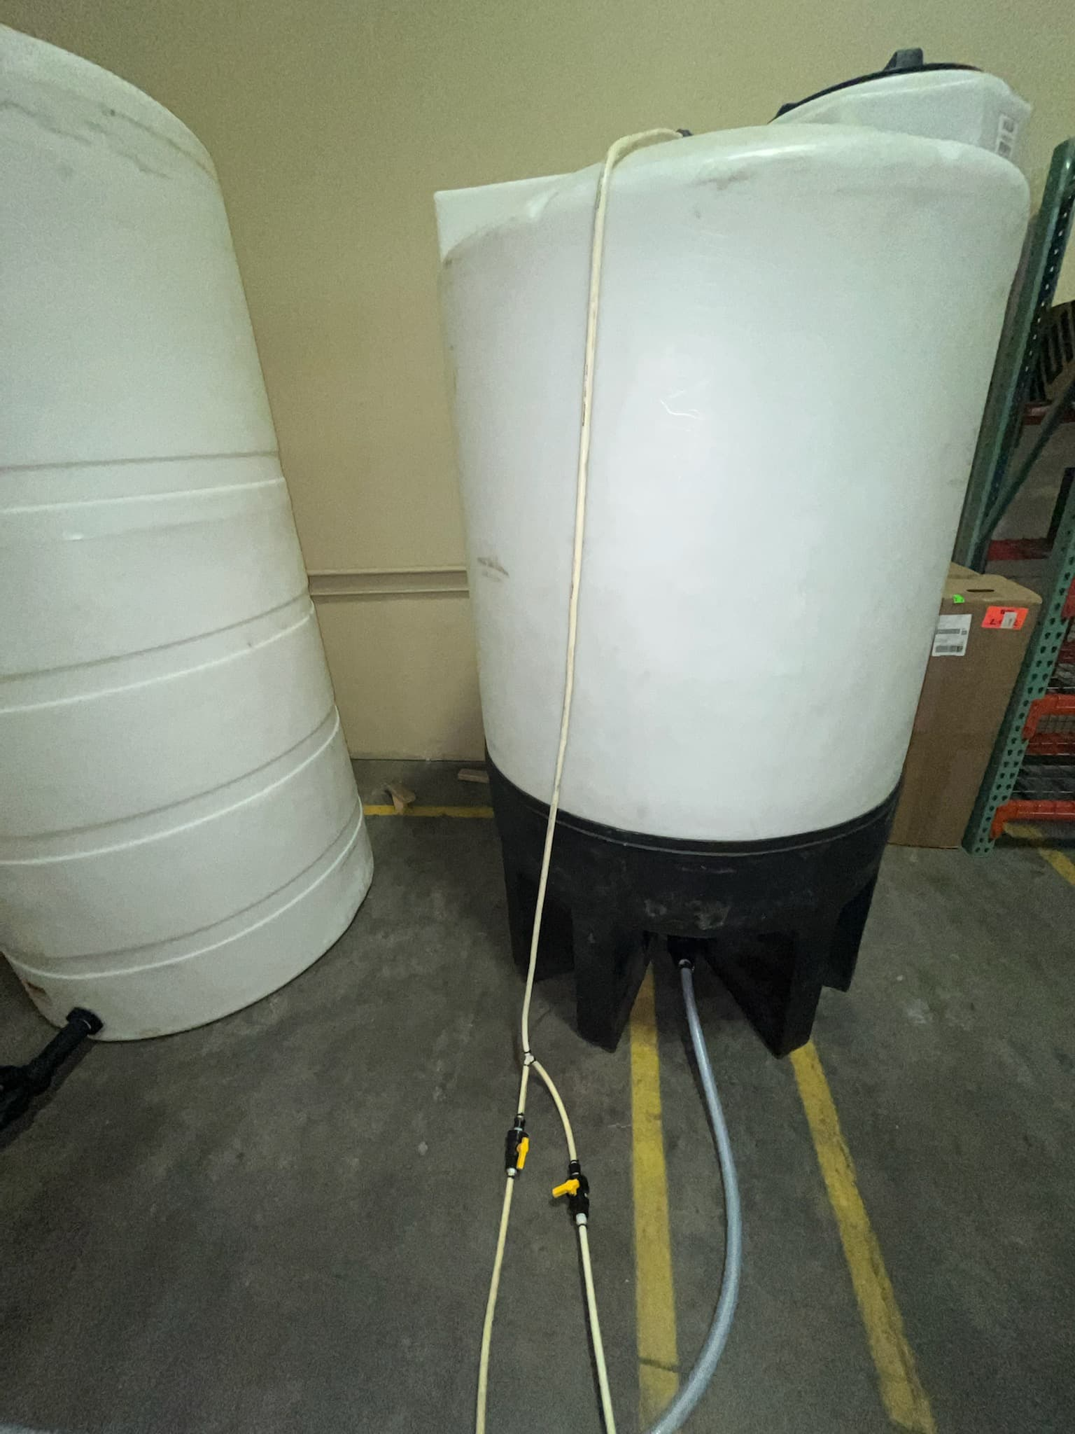
High Purity Water Tank Assembly, Waste Tank Assembly, and connecting lines
High Purity Water Tank Assembly
Waste Tank Assembly
Waste Line
Waste Line Valve (Horizontal position)
Permeate Line Valve (Vertical position)
Permeate Line

Procedure: Line Clearance

Perform line clearance of the work area in accordance with Workstation Practices QM.SLQ049.

Procedure: KTF-2000 System Initialization

Turn on the System Control Panel of the KTF-2000 System (E.SLQ006).

Initialize system software.

Enter login credentials:

User account: Spectr

Password: 3255.

Procedure: System Preparation

Verify the conductivity indicator on the Portable Exchange Deionizer System (E.SLQ001) is green.

If the indicator is red, discontinue system preparation contact the appropriate service provider to resolve.

System preparation and production may continue at risk provided that the High Purity Water (S.SLQ001) at the outlet of the Portable Exchange Deionizer System is tested for water quality in accordance with QM.SLQ051.

Place Containers (S.SLQ003) below Pump 01 and Pump 02 of the KTF-2000 System.

Disconnect the clamps holding the plug on Pumps 01 and 02 and allow liquid to drain into the containers.

Turn the Waste Line Valve into the vertical (open) position and the Permeate Line Valve into the horizontal (closed) position (figure in Section 9.5 indicates the valve system). Using the Peristaltic Pump (E.SLQ011) and the waste line, drain containers into the waste tank (E.SLQ004).

Connect Retentate Line 1A to Pump 01 and Retentate Line 2A to Pump 02.

Disconnect the clamps holding the plug above Membrane Module 1 and Membrane Module 2.

Connect Retentate Line 1B to Membrane Module 1 and Retentate Line 2B to Membrane Module 2.

Place Retentate Line 1B through Flow Meter 1 and Backpressure Valve 1 and Retentate Line 2B through Flow Meter 2 and Backpressure Valve 2.

Place Feed Line 1 into Pump 03 and Feed Line 2 into Pump 04.

Place Permeate Line into the Peristaltic Pump (E.SLQ011). Change the Waste Line Valve to the horizontal (closed) position and the Permeate Line Valve to the vertical (open) position.

Press ‘Zero’ on Control Panel of the Concentrate Reactor Floor Scale (E.SLQ010) to tare the floor scale.

Fill Concentrate Reactor with High Purity Water (S.SLQ001) until the floor scale reads ~30 kg. Record value in traveler.

Ensure that the ‘Feed (Remaining)’ value on the system software is within ±0.2kg of the reading on the floor scale.
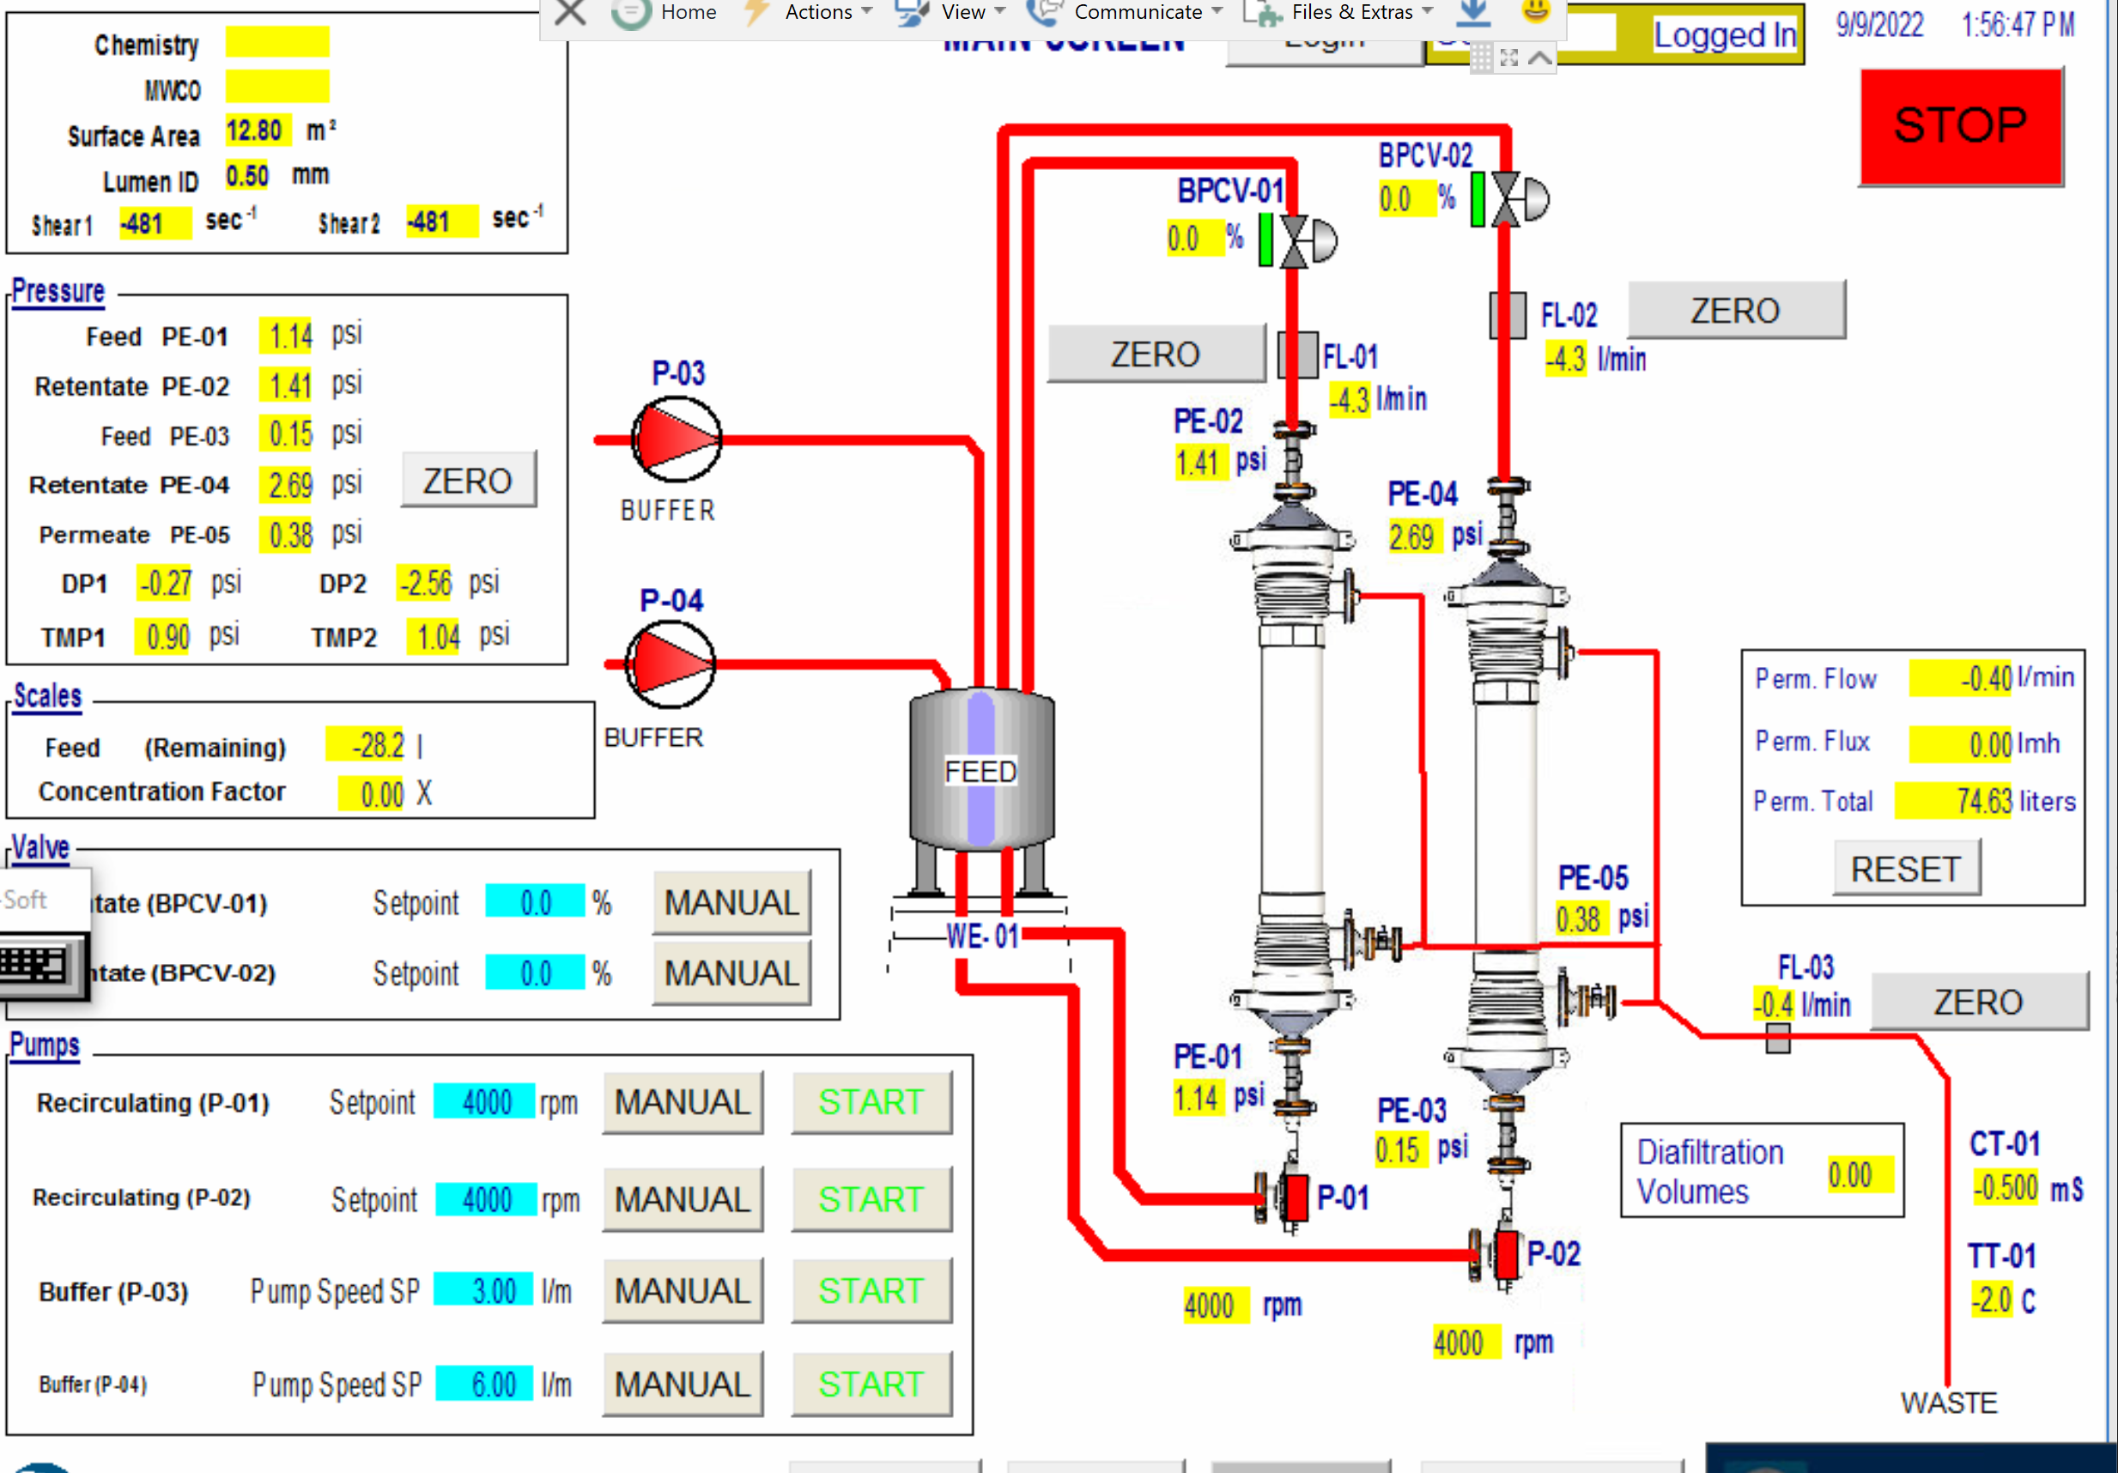

Press the START buttons highlighted below on the system software to manually run Pump 01 and Pump 02 as shown below until Membrane Modules 1 and 2 and Retentate Lines 1A, 1B, 2A, and 2B are filled.
Note: User may be required to elevate Retentate Lines 1A or 2A so water is able to reach the pumps.

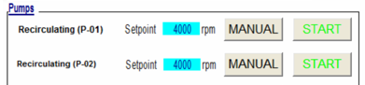

Ensure all connections are secure and no leaks are present.

Again, fill Concentrate Reactor until the floor scale reads ~30 kg.

Set the following parameters on main page of the system software:

Starting Volume: 30 L

DV Setpoint: 2.0 DV

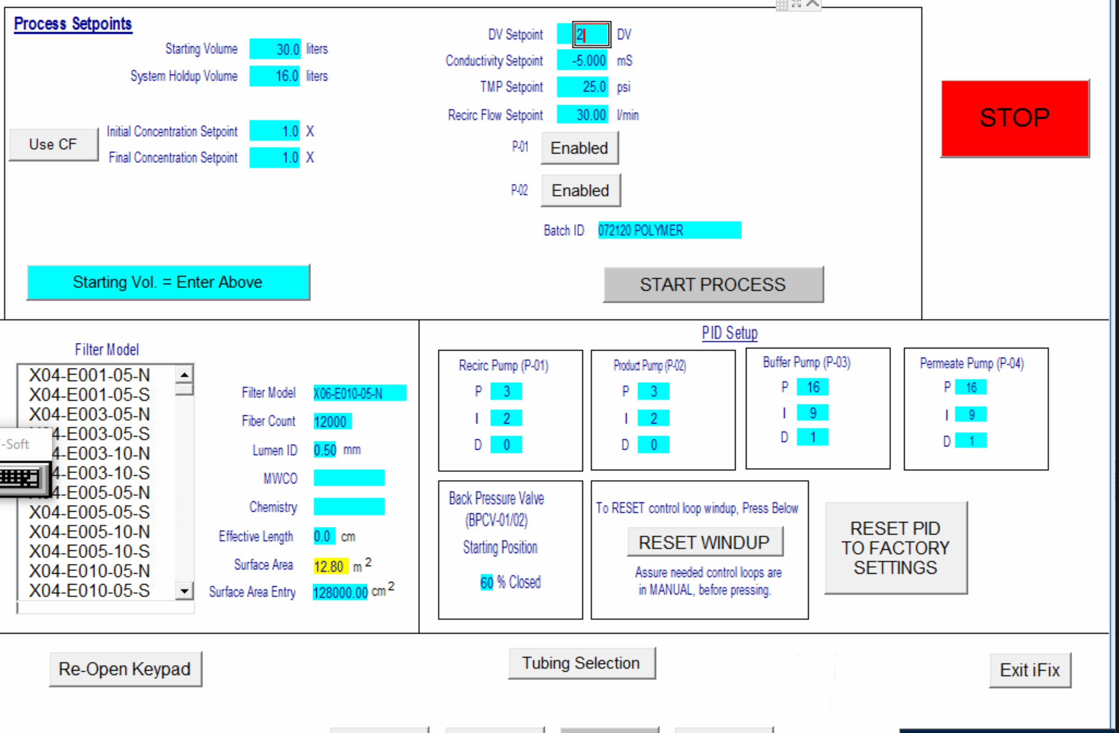

Click the START PROCESS button.

After Membrane Module 1 and Membrane Module 2 are filled with water, ensure the Permeate Valve is set to the vertical position and open the four clamps on permeate line.

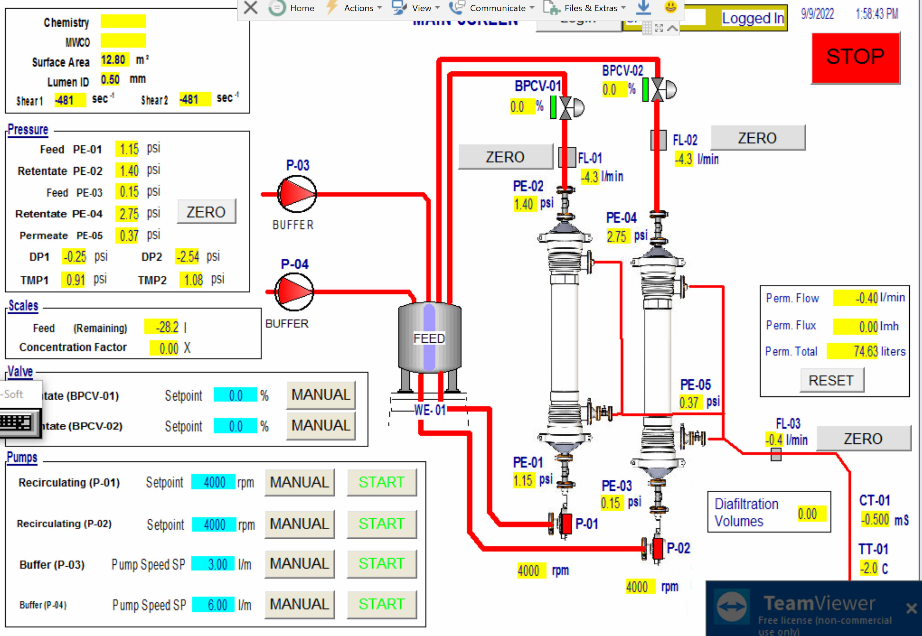
Continue to run process until ‘Perm. Total’ value reads 60L in the system software. Click Stop.

Mount Pneumatic Drum Stirrer (E.SLQ007) into Holder and turn on air, roughly 45° or more on the air inlet valve so that the water in the Concentrate Reactor is lightly stirred.

Procedure: Suspension Processing

Obtain the designated Unpurified Polymeric Dispersion Solution (M.SLQ001) container(s) for the production work order. Record material traceability information on the traveler.

Record volume of container(s) on the traveler.

Fill the Concentrate Reactor with High Purity Water until the Designated Fill Value (DFV) equals the volume of the container(s). Record the DFV in the traveler.
Note: The minimum DFV value and volume of Unpurified Polymeric Dispersion Solution should be 20L.

Calculate the Designated Operating Value (DOV). The DFV is 30% of the DOV.
DOV = 10 / 3 * DFV
Record the DOV in the traveler.

Slowly pour contents of the Unpurified Polymeric Dispersion Solution container(s) into the Concentrate Reactor as the pneumatic drum stirrer continues stirring. Pause if necessary to ensure that no gelation develops.


Fill the Concentrate Reactor with High Purity Water until the DOV is reached (within ±2kg) as read by the floor scale and “Feed (Remaining)” field on the system software. Verify both the floor scale and system software are within ±2kg of DOV and each other. Record values on the traveler.

Set parameters on main page of system software as shown

Starting Volume: Designated Operating Value

DV Setpoint: 10 DV

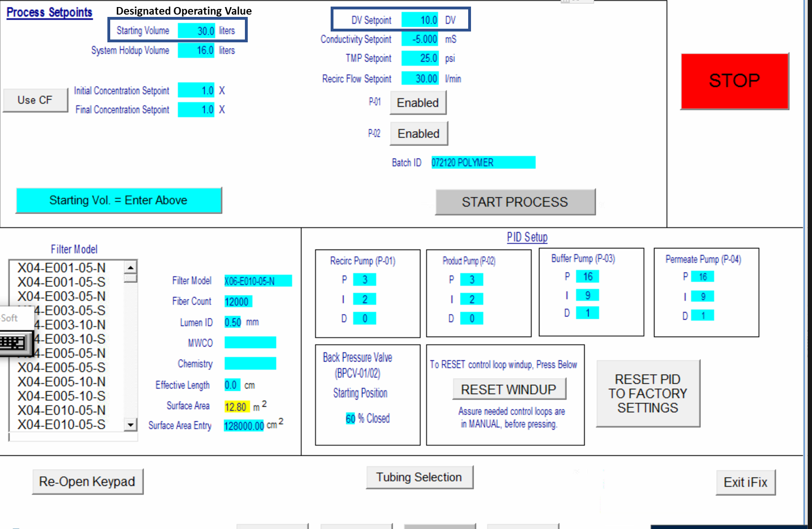

Click START PROCESS button. Verify both Pump 01 and Pump 02 are running.
Note: User may be again required to elevate Retentate Lines 1A or 2A so solution is able to reach the pumps.


Run process until ‘Perm. Total’ value reaches 10 times the value of the DOV. Click STOP button.

Procedure: Transferring suspension to final packaging

Place a Product Tank (55 gallon Plastic Drum C.SLQ003) onto the Suspension Floor Scale (E.SLQ012). Record the weight of the product tank on the traveler.

Zero (e.g., tare) the Suspension Floor Scale.

Disconnect the Permeate Line from the Peristaltic Pump and connect Product Line to the Peristaltic Pump (E.SLQ011). Insert the ends of the Product Line into the Concentrate Reactor and Product Tank appropriately. Turn on the Peristaltic Pump to begin the transfer of the contents of the Concentrate Reactor to the Product Tank.

During the suspension transfer process, fill three 50 mL tubes (S.SLQ002) with aliquots of suspension solution for quality analysis at the beginning, middle, and end of the transfer process. Label the tubes Aliquot A, Aliquot B, and Aliquot C, respectively.

Reconnect Permeate Line to the Peristaltic Pump.

Place clean containers (S.SLQ003) below Pump 01 and Pump 02. Disconnect Retentate Line 1A from Pump 01 and Retentate Line 2A from Pump 02. Allow suspension to drain into containers and pour the contents into the Product Tank. Reconnect Retentate Line 1A to Pump 01 and Retentate Line 2A to Pump 02.

Record the Initial Suspension Weight of the Product Tank using Suspension Floor Scale in the traveler.
Assumption: The initial weight (in kg) of the suspension is equal to the initial volume (in L).

Seal the Product Tank.

Print two copies of the product label for the Suspension (L.SLQ005) entering the part revision, lot number, and expiration date. The expiration date is two (2) years from the date of manufacturing. Apply one product label to the product tank. Apply the other product label to the DHR.

Place the product tank in quarantine pending QC analysis of the Suspension and DHR review & release.

Perform QC analysis on suspension samples in accordance with QC-C.SLQ001.

Once the QC analysis has been performed, attach the Suspension Quality Control Report and COA to the DHR and submit to QA for review and release of product.

Confirm test results documented in the COA meet acceptance criteria.

Note: The diafiltration system, equipment, and supplies should be prepared for storage (Section 15) immediately after Step 14.10.

Procedure: Prepare diafiltration system, equipment, and supplies for storage

Preparing KTF-2000 System for Storage

Fill Concentrate Reactor with High Purity Water until the floor scale reads ~30 kg. Verify that the ‘Feed Remaining’ matches the reading on the scale.


Click the START button to manually run Pump 01 and Pump 02 as shown below until Membrane Modules 1 and 2 and Retentate Lines 1A, 1B, 2A, and 2B are filled.

Continue to allow Pump 01 and Pump 02 to run for 10 minutes and then click the STOP button on each pump

Switch the Permeate Line Valve to the horizontal (closed) position and the Waste Line Valve to the vertical (open) position.

Place Waste Line through the Peristaltic Pump and into the Concentrate Reactor.

Manually run the Peristaltic Pump to fully drain the contents of the Concentrate Reactor into the Waste Tank.

Add 20L of High Purity Water to clean container followed by 1.5mL of bleach solution (S.SLQ007) to create Storage Solution.

Add Storage Solution to Concentrate Reactor. Close the four Permeate Line clamps and switch Permeate Line Valve to horizontal (closed) position and Waste Line Valve to vertical (open) position.


Click the START button to manually run Pump 01 and Pump 02 as shown below until Membrane Modules 1 and 2 and Retentate Lines 1A, 1B, 2A, and 2B are filled.

Once filled, stop Pump 01 and Pump 02 and close the ball valves for Retentate Lines 1B and 2B at the Concentrate Reactor. Allow 5 minutes to elapse for settling and degassing. Ensure the Storage Solution has filled Membrane Modules 1 and 2 entirely. Storage Solution should at least fill Retentate Lines 1B and 2B up to the respective line’s Flow Meter.

If the Storage Solution level has fallen below the Flow Meter in either line, repeat step 15.1.9 and 15.1.10.

Manually run the Peristaltic Pump to fully drain the contents of the Concentrate Reactor into the Waste Tank.

Power down Pump 01, Pump 02, the Concentrate Reactor Scale, Suspension Scale, and the KTF System Software.

Procedure: Preparing the High Purity Water Tank for Storage

The high purity water tank is to be stored empty and dry when not in use.

Take a peristaltic pump with sterilized tubing to pump out any residual high purity water from the tank.

Allow high purity water tank to dry for 24 hours before securing lid to the tank.

Procedure: Clean supplies

Clean containers used in the manufacturing process with commonly used cleaning agents. Allow containers to dry. Store containers after they have dried.

Procedure: Suspension Dilution

The manufacturing process is designed to produce suspension at a concentration greater than the intended target concentration of use (1% w/v). Therefore, after suspension quality analysis has been performed, a specific amount of High Purity Water will be added to the Product Tank to dilute the suspension from its initial concentration to the intended target concentration of use, 1% w/v.

Calculate the Average Suspension Sample Concentration (g/L) by taking the average ‘Residue Net Weight’ of six (6) freeze dried suspension samples based off the 10 mL sample. (The ‘Residue Net Weight’ can be found in the Suspension Quality Control Report.)

Calculate the volume (L) of High Purity Water to be added to the product tank using the formula below:

Volume = [Average Suspension Sample Concentration (g/L) * Initial Suspension Volume (L)]/[10 (g/L)] – Initial Suspension Volume (L)

Record the volume in the traveler.

Obtain the product tank from quarantine. Tare the Suspension Floor Scale.

Place the product tank on the floor scale and add the determined amount of high purity water to the product tank.

Record the weight of the product tank.

Calculate the weight of the suspension by subtracting the weight of the product tank from Step 14.1.

Update the product label for the Suspension (L.SLQ005) with the suspension weight.

Suspension Concentration Process

The manufacturing process is designed to produce suspension at a concentration greater than the intended target concentration of use (1% w/v). If, after suspension quality analysis has been performed, it is found that the polymer concentration of the lot is below the target concentration, this additional concentration step shall be performed and the quality analysis procedure shall be subsequently repeated. Operators shall perform the Suspension Concentration process according to the following steps and fill out the “Build Record Concentration Process” section of the traveler accordingly.

Calculate the Concentration Permeate Required Value according to the following calculation

Concentration Permeate Required = [12 (g/L)-Average Suspension Sample Concentration (g/L)]/ 12 (g/L) * Initial Suspension Volume (L) + 16 (L)

Perform System Preparation procedure outlined in Section 12.

Disconnect the Permeate Line from the Peristaltic Pump and connect Product Line to the Peristaltic Pump (E.SLQ011). Insert the ends of the Product Line into the Concentrate Reactor and Product Tank appropriately. Turn on the Peristaltic Pump to begin the transfer of the contents of the Product Tank to the Concentrate Reactor.

Run process until ‘Perm. Total’ value reaches the Concentration Permeate Required Value.

Perform Procedure: Transferring suspension to final packaging steps outlined in Section 14 including all sampling activities.

Perform Procedure: Prepare diafiltration system, equipment, and supplies for storage steps outlined in Section 15.

Appendix A: System Diagram, Suspension Processing

